**TCP-IP Networking Week 12 Homework**

**Working Instructions**

**Step 1:** Build docker image using the java source files.

Command: **docker build -t saketh360/chatserver .**

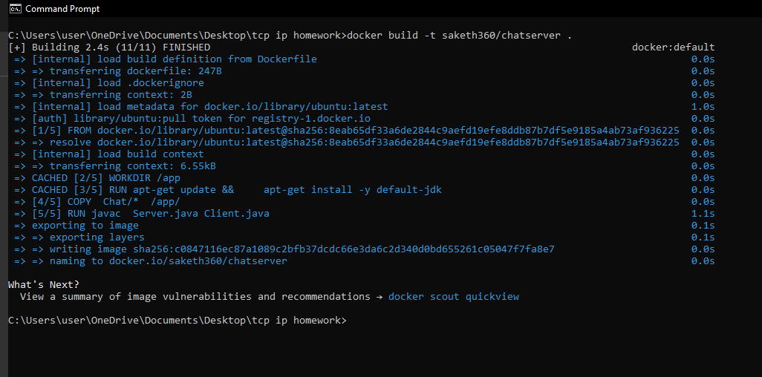

**Step 2:** Push the newly created image into docker hub.

Command: **docker push saketh360/chatserver**

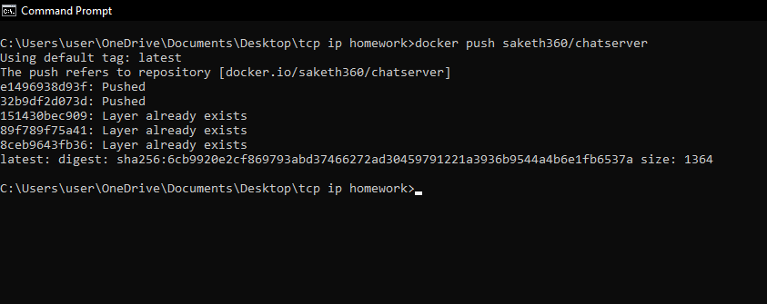

**Step 3:** Start the minikube service

Command: **minikube start**

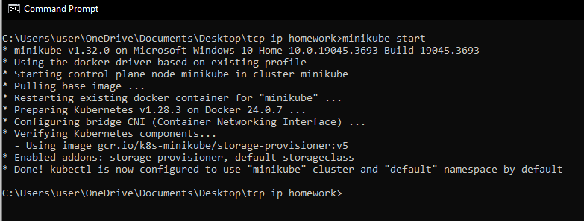

**Step 4:**  Check the number of pods in the kubernetes cluster at this moment for verification

Command: **kubectl get pods**

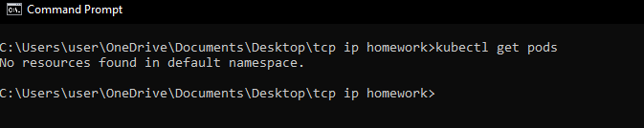

There are no pods available at this moment.

**Step 5:** Create the pods using the deployment.yaml file

Command: **kubectl create -f deployment.yaml**

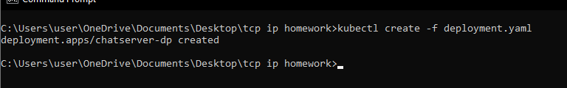

**Step 6:** Create the nodeport service using service.yaml file

Command: **kubectl apply -f service.yaml**

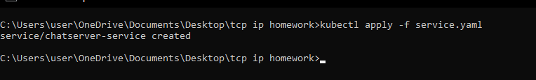

**Step 7:** Verify the creation of pod and service using the below commands.

Command 1: **kubectl get pods**

Command 2: **kubectl get services**

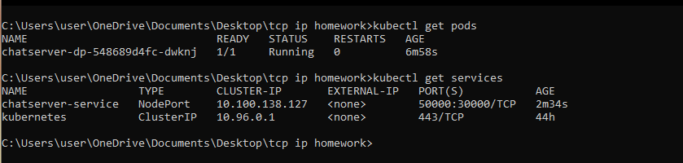

**Step 8:** Find the URL and port number of the chatserver application.

Command: **minikube service chatserver-service –url**

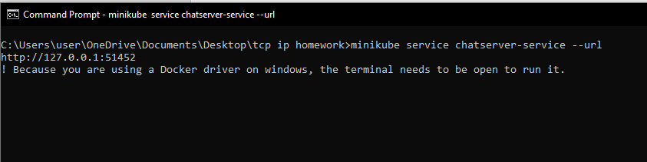

**Step 9:** Connect to the server using the URL and Port Number. To do so, open a new cmd prompt session and run the Client Code with the port number.

Command: **java Client 51452**

